EXPERIMENT-1

1. whoami To get the username

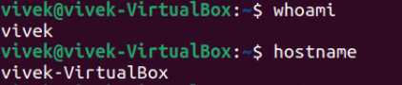

1. hostname To get the hostname



1. ls to list the directories
2. 
3. ls -al List the directories including hidden and with other details

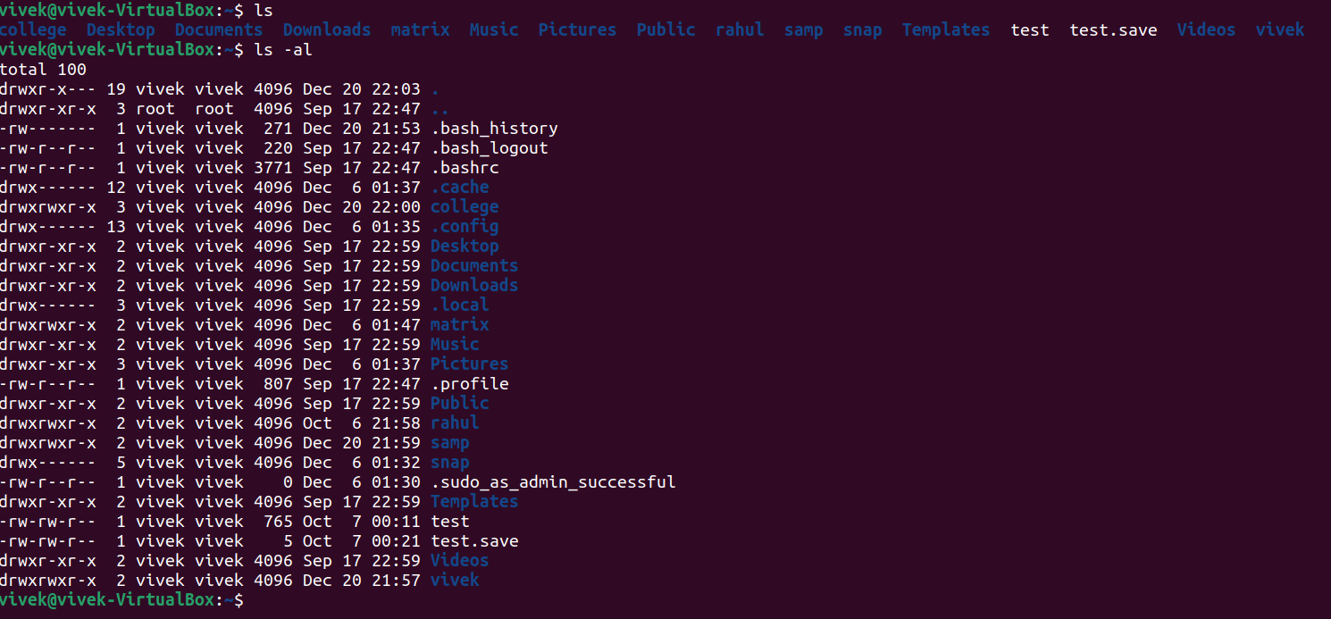

1. pwd To see the directory you are currently working with



1. cd <directory name> : To enter the directory

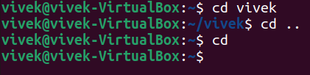

1. cd .. To go to the previous directory



1. cd To go to home directory



1. touch <file name> To create a file



1. vi / nano Open the writing mode

vi

nano

1. vi / nano <file name> create a file and open in writing mode

1. cat <file name> To read file and add content(cat >> filename)

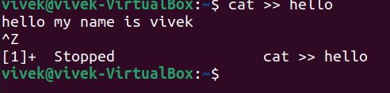

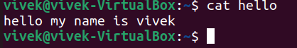

1. mkdir<directory name> create a directory



1. mkdir -help help in mkdir

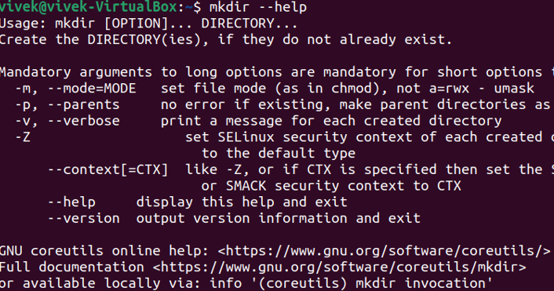

1. mkdir -v <directory name> create a directory and give output for status



1. mkdir -p <directory name/next directory> Create a directory path Text

   Description automatically generated
2. rm <file name> to delete a file, rmdir <directory name> delete directory

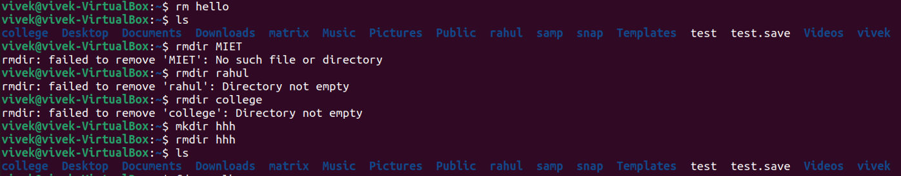

1. mv <old file name> <new file name> to renaming a file

